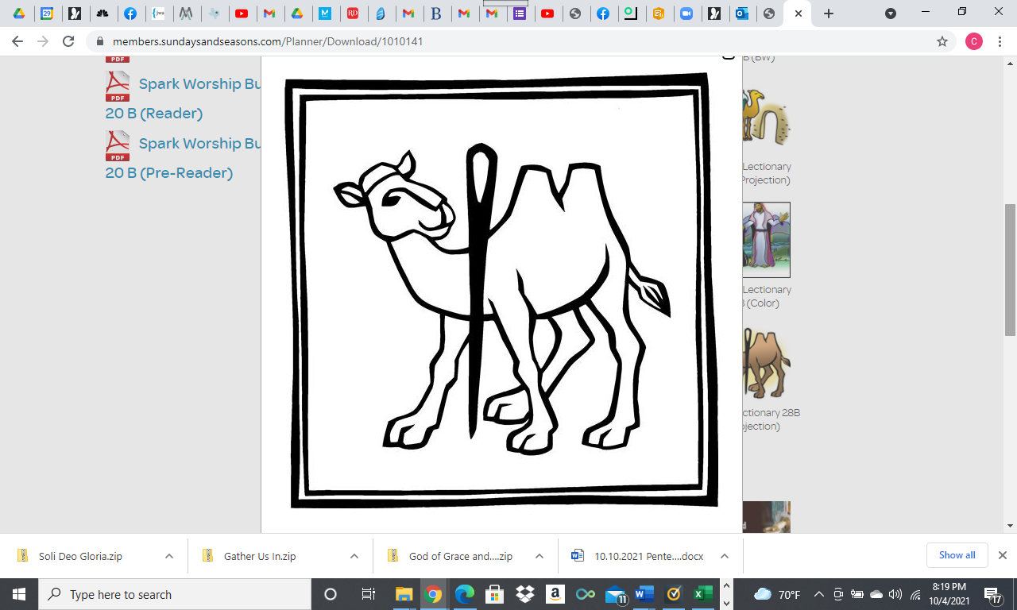

**Twentieth Sunday after Pentecost**

**October 10th, 2021 9:30 am**

**Zoom Holy Communion Worship Service**

**ZOOM 706 565 767, Passcode 767**

**SHEPHERD OF THE HILLS LUTHERAN CHURCH**

**4887 Valleydale Road, Birmingham, AL 35242**

**(205) 995-9673** **www.sothl.org**

We pray that our time together will be an inspiration to all. Our order of worship is Setting Four from the Evangelical Lutheran Worship (ELW red). Our order of worship is printed in its entirety below. **Congregation** responses are indicated in **bold** print, P: Pastor, **C: Congregation**

|  |  |
| --- | --- |
| **SOTH hills**  **Welcome to**  **Shepherd of the Hills**  **Lutheran Church**  *“A Place to Call Home”* | ***Our Mission Statement***  *Shepherd of the Hills Lutheran Church seeks to demonstrate God’s grace, to learn and grow in the Christian faith, and to serve with humility.*  ***Our Welcoming Statement***  *As an inclusive congregation, we welcome all into God’s love and grace without regard to:*  *Ability * Age * Beliefs * Culture * Ethnicity * Gender Identity * Income * Language * Life Circumstances * Marital Status * Race * Sexual Orientation*  ***As God’s grace welcomes all, we are united in Christ*** |
| **Thank you for worshiping with us today. If you need assistance following the order of worship, feel free to ask your neighbor for help. May this time of worship encourage and strengthen you for the week ahead. We hope you’ll worship with us again.**  **Pastor**: Carolyn Hayford (803) 606-6683 **Secretary**: Liz Satterfield (205) 995-9673  **Musician**: Ann Jones (205) 902-2444 **Council President**: Larry Smith (205) 988-6449  **Soloist**: Eric Campbell | |
| **Serving us today in Worship:**   |  |  |  |  | | --- | --- | --- | --- | | **Worship Assistant:** | Ron Wooster | **Zoomster:** | Marie Prine | | **Reader:** | John Boettner | **Head Zoom Usher:** | Peggy Huckabaa | | **Children’s Message:** | Peggy Huckabaa | **A/V:** | Gene Myers | | **Music:** | Ann Jones | **Soloist:** | Eric Campbell |   Please check out our new and improved website: www.sothl.org.  Note that pictures taken at various church events and services are posted on both our website and our Facebook page. If you do not want your picture to appear on our page or on the web site for any reason, please alert the church office at office@sothl.org or 205-995-9673 so that your request can be honored. | |

**Order of Worship**

**Twentieth Sunday after Pentecost**

October 10th, 2021

**WELCOME AND ANNOUNCEMENTS**

**HOLY COMMUNION DISTRIBUTION Today** 1-2 pm in the SOTHL upper parking lot. Please consider bringing snacks for IES or breakfast bars, plastic sacks you are ready to recycle and cereal for the Food Pantry to drop off when you come for communion. Thank you for your generosity.

**MY YOUNG FRIENDS!!!** Today's Bible story is "A Rich Man's Question" on page 334 in

your *Spark Story Bible*.  If you don't have a *Spark Story Bible* you can read the story in any Bible

in Mark 10:17-31.

**BLOOD DRIVE** 10/13/21 at SOTHL from 1-6 PM Please sign up to donate. To volunteer to staff, contact Pastor, the office or Susan Pritchett.

**PRELUDE** Gather Us In arr: Elizabeth Jordan

**CONFESSION AND FORGIVENESS**

P: Blessed be the holy Trinity, ☩ one God, full of compassion and mercy, abounding in steadfast love.

**C: Amen**

A: Trusting God’s promise of forgiveness, let us confess our sin against God and one another.

*Silence for reflection and self-examination*

A: Eternal God our creator,

**C: In you we live and move and have our being. Look upon us, your children, the work of your hands. Forgive us all our offenses, and cleanse us from proud thoughts and empty desires. By your grace draw us near to you, our refuge and our strength; through Jesus Christ our Lord. Amen.**

P: Since we are justified by faith, we have peace with God through our Lord Jesus Christ. God’s love has been poured into our hearts through the Holy Spirit given to us. In the mercy of almighty God, Christ died for us while we still were sinners; and for his sake, God ☩ forgives you all your sins.

**C: Amen.**

**GATHERING HYMN** ELW 878 Soli Deo Gloria - verses. 1,4,5

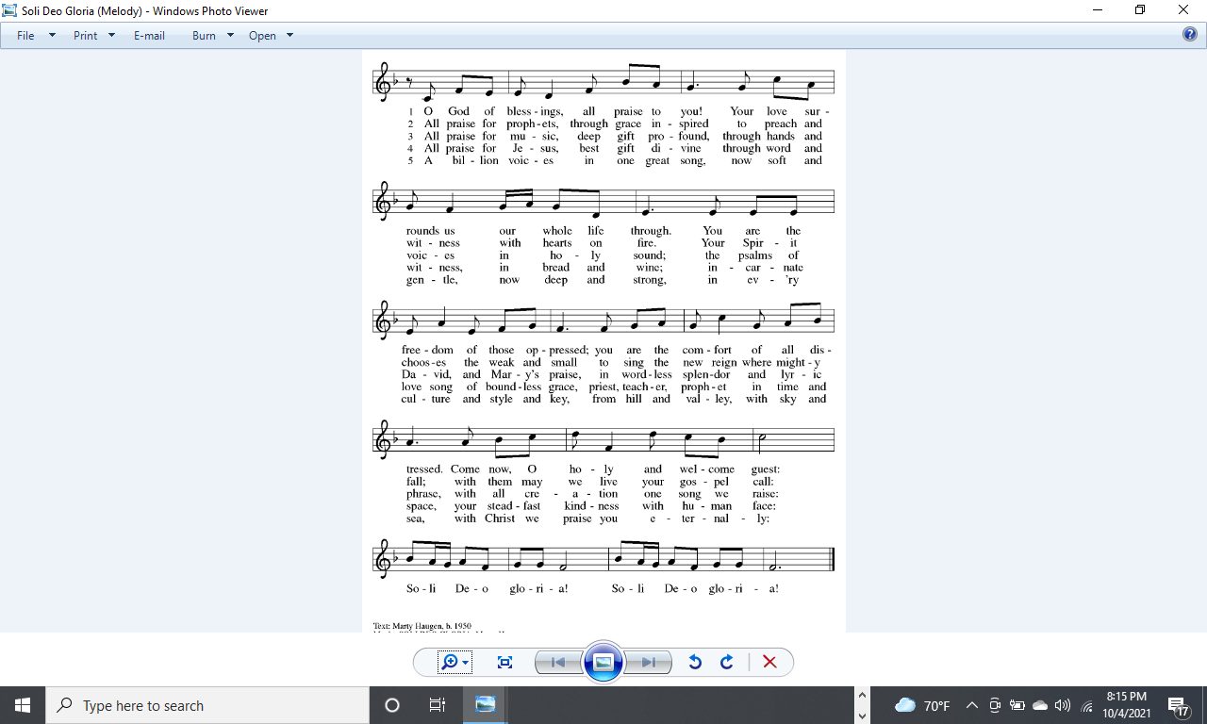









**Greeting**

P: The grace of our Lord Jesus Christ, the love of God, and the communion of the Holy Spirit be with you all.

**C: And also with you**

**KYRIE**

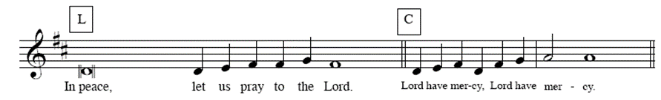

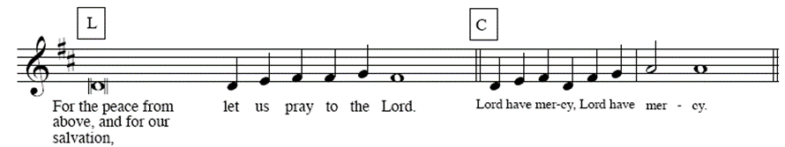

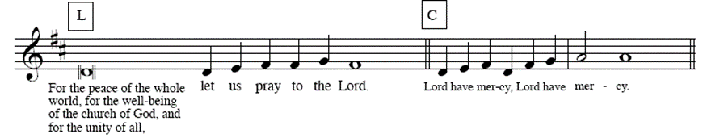

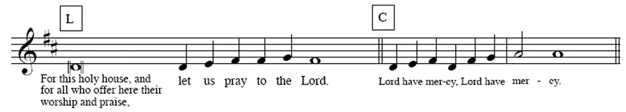

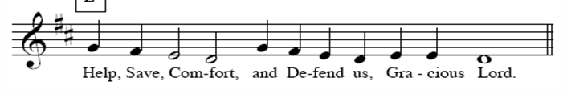

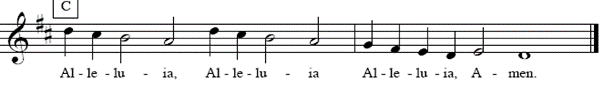

**Prayer of the Day**

A: Let us pray.

A: Almighty and ever-living God, increase in us your gift of faith, that, forsaking what lies behind and reaching out to what lies ahead, we may follow the way of your commandments and receive the crown of everlasting joy, through Jesus Christ, our Savior and Lord.

**C:** **Amen.**

**CHILDREN’S MESSAGE**

**THE FIRST READING:** Amos 5:6-7, 10-15

*Amos was a herdsman by profession and a prophet by God’s call. During a time of great prosperity in the northern kingdom of Israel, the prophet speaks to the wealthy upper class. He warns his listeners that fulfilling God’s demand for justice brings blessing, while corruption and oppression incur God’s wrath.*

6Seek the Lord and live, or he will break out against the house of Joseph like fire, and it will devour Bethel, with no one to quench it. 7Ah, you that turn justice to wormwood, and bring righteousness to the ground!   
 10They hate the one who reproves in the gate, and they abhor the one who speaks the truth.  11Therefore because you trample on the poor and take from them levies of grain, you have built houses of hewn stone, but you shall not live in them; you have planted pleasant vineyards, but you shall not drink their wine. 12For I know how many are your transgressions, and how great are your sins— you who afflict the righteous, who take a bribe, and push aside the needy in the gate. 13Therefore the prudent will keep silent in such a time; for it is an evil time.  
  
 14Seek good and not evil, that you may live; and so the Lord, the God of hosts, will be with you, just as you have said. 15Hate evil and love good, and establish justice in the gate; it may be that the Lord, the God of hosts, will be gracious to the remnant of Joseph.

R: The word of the Lord.

**C: Thanks be to God.**

**THE PSALM** *Please* *read Psalm 90: 12-17 responsively.*

12So teach us to number our days that we may apply our hearts to wisdom.

13**Return, O Lord; how long will you tarry? Be gracious to your servants.**

14Satisfy us by your steadfast love in the morning; so shall we rejoice and be glad all our days.

15**Make us glad as many days as you afflicted us and as many years as we suffered adversity.**

16Show your servants your works, and your splendor to their children.

17**May the graciousness of the Lord our God be upon us; prosper the work of our hands; prosper our handiwork.**

**Second Reading:** Hebrews 4:12-16

We cannot hide our thoughts, desires, and actions from God, to whom we are completely accountable. Nevertheless, Jesus understands our human weakness and temptations, because he also experienced them. Therefore we can approach the throne of grace to receive divine mercy from Christ.

12Indeed, the word of God is living and active, sharper than any two-edged sword, piercing until it divides soul from spirit, joints from marrow; it is able to judge the thoughts and intentions of the heart. 13And before him no creature is hidden, but all are naked and laid bare to the eyes of the one to whom we must render an account.  
  
  14Since, then, we have a great high priest who has passed through the heavens, Jesus, the Son of God, let us hold fast to our confession. 15For we do not have a high priest who is unable to sympathize with our weaknesses, but we have one who in every respect has been tested as we are, yet without sin. 16Let us therefore approach the throne of grace with boldness, so that we may receive mercy and find grace to help in time of need.

R: The word of the Lord.

**C: Thanks be to God.**

**GOSPEL ACCLAMATION**





### 

### THE HOLY GOSPEL: Mark 10:17-31

### C: Glory to you, O Lord.

Jesus has been teaching his disciples about what is most valued in God’s eyes. Now, a conversation with a rich man brings his message home to the disciples in a way that is surprising but unforgettable.

17As [Jesus] was setting out on a journey, a man ran up and knelt before him, and asked him, “Good Teacher, what must I do to inherit eternal life?” 18Jesus said to him, “Why do you call me good? No one is good but God alone. 19You know the commandments: ‘You shall not murder; You shall not commit adultery; You shall not steal; You shall not bear false witness; You shall not defraud; Honor your father and mother.’ ” 20He said to him, “Teacher, I have kept all these since my youth.” 21Jesus, looking at him, loved him and said, “You lack one thing; go, sell what you own, and give the money to the poor, and you will have treasure in heaven; then come, follow me.” 22When he heard this, he was shocked and went away grieving, for he had many possessions.

  23Then Jesus looked around and said to his disciples, “How hard it will be for those who have wealth to enter the kingdom of God!” 24And the disciples were perplexed at these words. But Jesus said to them again, “Children, how hard it is to enter the kingdom of God! 25It is easier for a camel to go through the eye of a needle than for someone who is rich to enter the kingdom of God.” 26They were greatly astounded and said to one another, “Then who can be saved?” 27Jesus looked at them and said, “For mortals it is impossible, but not for God; for God all things are possible.”

  28Peter began to say to him, “Look, we have left everything and followed you.” 29Jesus said, “Truly I tell you, there is no one who has left house or brothers or sisters or mother or father or children or fields, for my sake and for the sake of the good news, 30who will not receive a hundredfold now in this age—houses, brothers and sisters, mothers and children, and fields, with persecutions—and in the age to come eternal life. 31But many who are first will be last, and the last will be first.”.

P: The gospel of the Lord.

**C: Praise to you, O Christ.**

**THE MESSAGE**

**THE HYMN OF THE DAY** ELW 532 Gather Us In - verses 1, 2 & 3

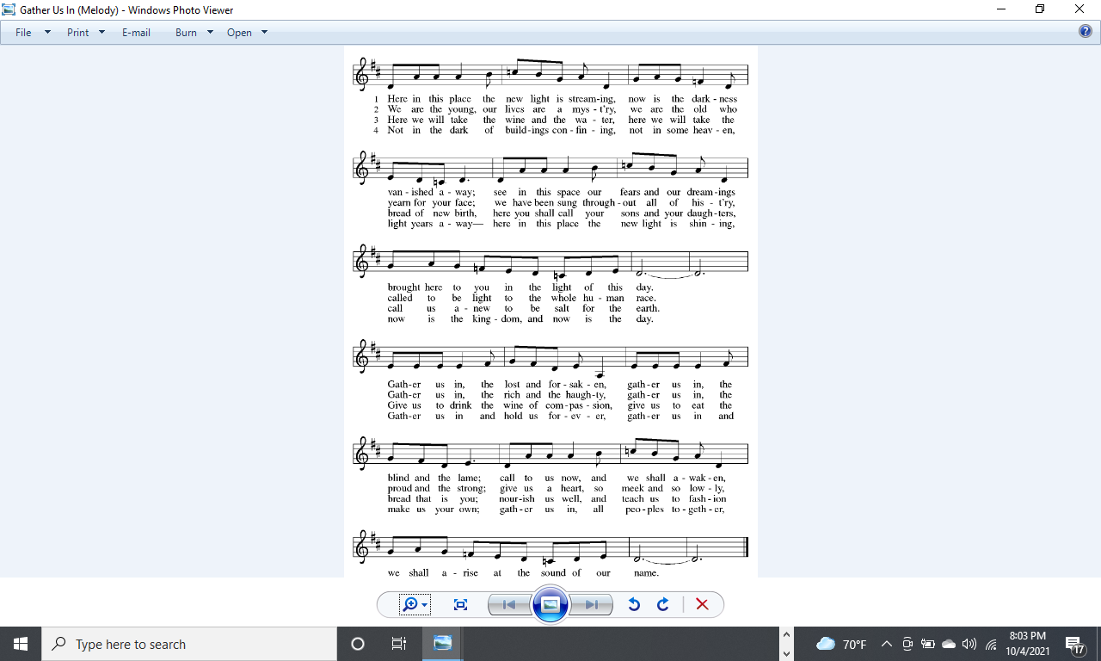 



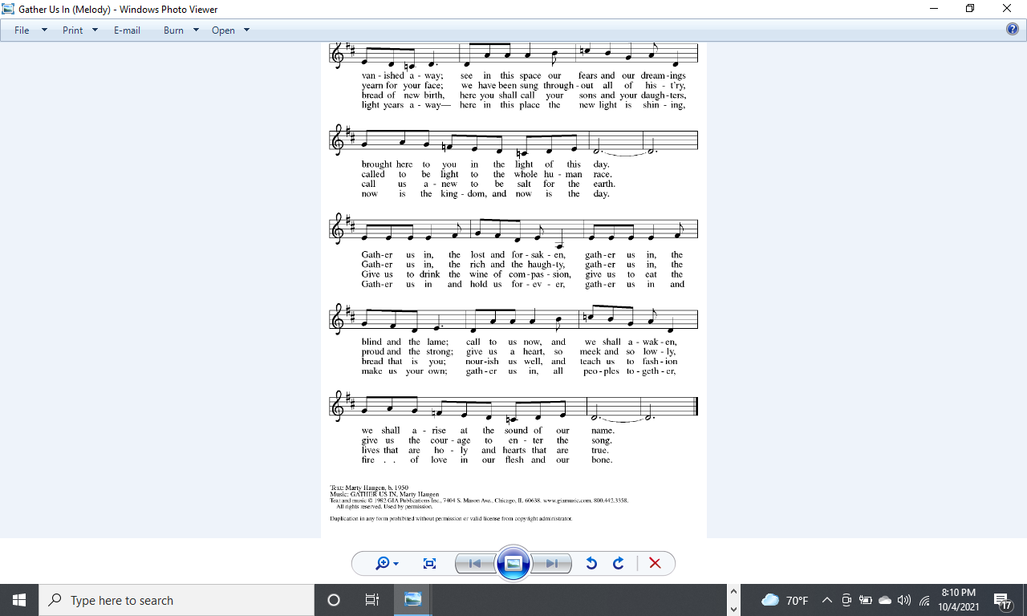

**THE APOSTLES CREED** ELW 105

A: Let us confess together our faith using the words of the Apostle’s Creed

**C: I believe in God, the Father almighty, creator of heaven and earth.**

**I believe in Jesus Christ, God's only Son, our Lord, who was conceived by the Holy Spirit, born of the virgin Mary, suffered under Pontius Pilate, was crucified, died, and was buried; he descended to the dead.**

**On the third day he rose again; he ascended into heaven, he is seated at the right hand of the Father, and he will come to judge the living and the dead.**

**I believe in the Holy Spirit, the holy catholic church, the communion of saints, the forgiveness of sins, the resurrection of the body, and the life everlasting. Amen.**

**THE PRAYERS OF THE CHURCH**

A**:** Lord, in your mercy **C: hear our prayer.**

*.*

**TITHES AND OFFERINGS**

A: The work and mission of the church continues no matter how we gather, in person, electronically, wherever two or more are gathered together in His name. Lord on this day, we bring our tithes and offerings, giving from the abundance that you have given us.

**THE OFFERING PRAYER**

A: Let us pray together,

**C:** **Merciful God, you open wide your hand and satisfy the need of every living thing. You have set this feast before us. Open our hands to receive it. Open our hearts to embrace it. Open our lives to live it. We pray this through Christ our Lord. Amen.**

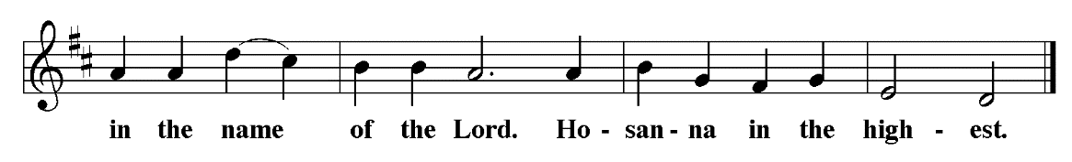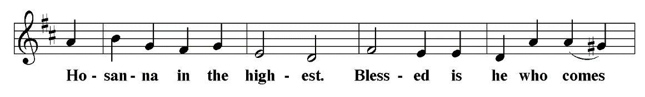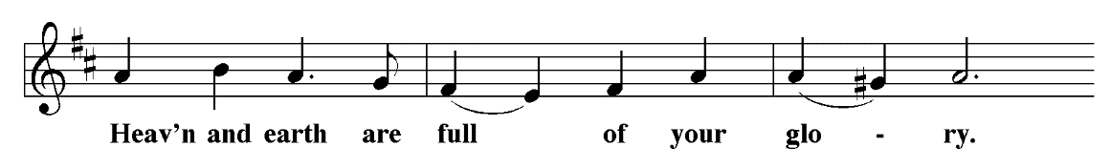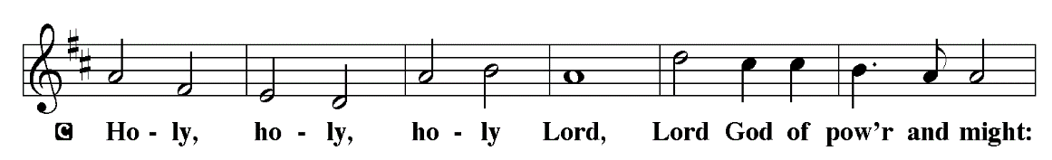**THE GREAT THANKSGIVING**

|  |
| --- |
|  |
|  |
| P:It is indeed right, our duty and our joy, **...** we praise your name and join their unending hymn: |

**EUCHARISTIC PRAYER**

**THE LORD’S PRAYER** (Please speak whichever version, in whatever language, you prefer.)

P: Gathered into one by the Holy Spirit, let us pray as Jesus taught us.

**C: Our Father in heaven, hallowed be your name, your kingdom come, your will be done, on earth as in heaven. Give us today our daily bread. Forgive us our sins as we forgive those who sin against us. Save us from the time of trial and deliver us from evil. For the kingdom, the power, and the glory are yours, now and forever. Amen.**

A: Speak to us, O Lord, in the breaking of the bread, and make us one with you.

**C: Thanks be to God.**

*Holy Communion will be distributed today from 1-2 pm in the SOTHL parking lot.*

**THE POST-COMMUNION PRAYER**

A:Holy and compassionate God, in bread and wine you give us gifts that form us to be humble and courageous. May your words come to life in our serving and in our witness, that we might speak a living voice of healing and justice to all the world, through Jesus Christ, our rock and our redeemer. **C: Amen**

**BLESSING**

P: People of God, you are Christ’s body, bringing new life to a suffering world.

The holy Trinity, ☩ one God, bless you now and forever.

**C: Amen.**

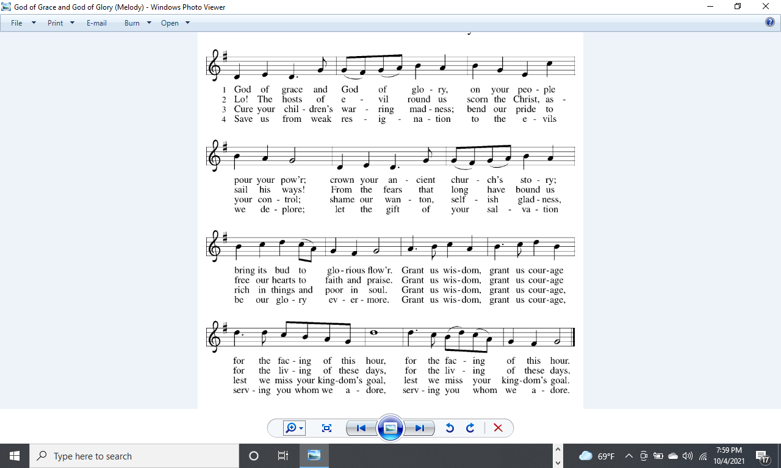**SENDING HYMN** ELW705 God of Grace and God of Glory - All verses







**DISMISSAL**

A: Go in peace. Serve the Lord.

**C: Thanks be to God.**

**POSTLUDE** Variations on Praise to the Lord, The Almighty arr: Greg Bottomley

Liturgy from Sundays and Seasons.com. Copyright 2021 Augsburg Fortress. All rights reserved. Reprinted by permission under Augsburg Fortress Liturgies Annual License. . ID #: SAS008054

**Next Week’s Lesson**

**THE FIRST READING:** Isaiah 53:4-12

**PSALM:** Psalm 91:9-16

**THE SECOND READING:** Hebrews 5:1-10

**THE GOSPEL:** Mark 10:35-45

**Intercessory Prayer**

We are a praying community; believing in the value of prayer.  We ask that you keep the congregation, our community, and all those on the prayer list insert in your prayers during the week. Prayer request cards can be found in the Narthex or in the back of the hymnal.

Please utilize the Intercessory Prayer insert during your prayers this week.

Worship Servants for **October 17:**

|  |  |  |  |
| --- | --- | --- | --- |
| **Worship Assistant:** | Carla Crowder | **Zoomster:** | Susan Pritchett |
| **Reader:** | Peggy Huckabaa | **Head Zoom Usher:** | Marie Prine |
| **Children’s Message:** | Kim Boettner | **A/V:** | Carrie Peters |
| **Music:** | Ann Jones | **Soloist:** | Eric Campbell |

**THIS WEEK AT SOTH**

**Sunday** 9:30 am E-Worship **Meeting ID** 706 565 767

**10/10** **Pass code** 767

10 min. after Service Adult Forum

12 pm Worship Committee

1-2 pm Distribution of Holy Communion **SOTHL Upper parking lot**

**Monday        7**:00 pm AA – New Hope, Alanon

**Tuesday** 7:00 pm           Zoom Social**/**Covid19 Q&A **Meeting ID** 706 565 767 **Pass code** 767

**Wednesday** 9:30 am Wednesday Bible Study **Meeting ID** 175 995 438

6:30 pm Prayer, Meditation and **Meeting ID** 706 565 767

Conversation **Pass code** 767

**Thursday**

**Friday**

**Saturday** 6:30 pm AA – New Hope

**OFFERING DONATIONS** – Each month, 2% of our General Fund offerings are donated to a local or ELCA ministry. The 2% of these offerings in October will be donated to _______

**ANNOUNCEMENTS**

**MY YOUNG FRIENDS!!** Today's Bible story is "A Rich Man's Question" on page 334 in your *Spark Story Bible*.  If you don't have a *Spark Story Bible* you can read the story in any Bible in Mark 10:17-31.

**HOLY COMMUNION DISTRIBUTION** – Today 1-2 pm in the SOTHL upper parking lot. Please consider bringing snacks for IES or breakfast bars, plastic sacks you are ready to recycle and cereal for the Food Pantry to drop off when you come for communion. Thank you for your generosity.

**INSPIRTUS** - Refugees and Afghan asylum seekers are being resettled through Inspiritus which was formerly called Lutheran Ministries of Georgia.  It is a Lutheran entity in the Southeastern Synod that works with Lutheran Immigration and Refugee services.  Ways you can help and be supportive to the resettlement of refugees/asylum seekers include:  be a volunteer, donate furniture/other items, help find employment for them. You can support Inspiritus financially either directly or through SOTH.

**FOOD PANTRY** Please consider either creating bags using the recipes on the website or create your own recipes and share them with us so we can put it in the rotation. If you would prefer, you can donate money instead to evangelism / outreach either on line (https://secure.myvanco.com/YM4V/home) or by check.  Thank you for your generosity.

**BLOOD DRIVE** Red cross blood drive is 10/13/21 at SOTHL from 1-6 PM Please sign up at https://www.redcrossblood.org/give.html/drive-results?zipSponsor=SOTHLC Also need volunteers to staff the event. Please reach out to Pastor, the office or Susan Pritchett to sign up.

**OPPORTUNITY FOR A LIFE CHANGING EXPERIENCE** – ELCA Southeastern Synod is sponsoring a trip – Cristo Rey Border Immersion Program at El Paso, Texas and Juarez, Mexico. March 12-19, 2022. Limited availability; only 14 participants. To find out more, go to https://enconjunto.weebly.com/2022-bie.html. Do not need to know Spanish.

**INTERESTED IN ADVOCACY?** The Southeastern Synod wants to know what who is interested in what issues and bring people together. Answer the survey by using this link**:**

**https://se-reg.brtapp.com/AdvocacySurvey54**

**COVID-19 Notifiers**: The COVID Task Force has established the following process to ensure we do not need to modify our current procedures and to help identify a potential cluster early: Anyone who attends a church event (even parking lot ones) or has been in the church building for any reason, and tests positive for COVID within 2 weeks of being there, is asked to contact one of the volunteers on this list below. Your name will be kept completely confidential. Thank you! Jared Brunswick, 205-531-5428, jrdbrunswick@yahoo.com; Erica Bjornstad, 443-717-0065, ericaecuador@yahoo.com; Susan Pritchett, 205-602-1282, sspritch@bellsouth.net.

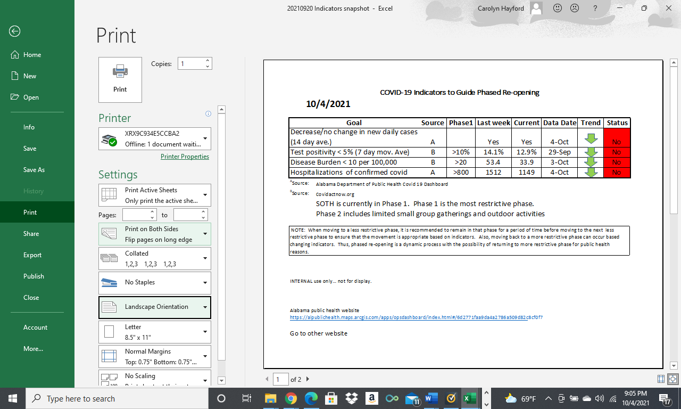

**WORSHIP MUSIC** - Wondering about the beautiful music you hear in our worship service? It’s Eric Campbell’s and Christine Wells’ voices. The piano is played by Ann Jones. We appreciate them sharing their gifts to the glory of God.

**ZOOM Meetings**

**SUNDAY – E - WORSHIP:**

Sundays at 9:30 am. Consider signing on early to catch up with friends and family.  The room is open at 9:00 am. Click on the link below:

https://us02web.zoom.us/j/706565767?pwd=MjJMbEIyM2pNMkkvaHJWNW1YSHU0UT09

Or call this number:  1-312-626-6799

Enter Meeting ID 706 565 767, Passcode 767

**SUNDAY – SPANISH PRAYER MINISTRY:**

Led by Pastor Ed Cortes – 1st Sunday in the Month at 2:30pm

Click this link: https://zoom.us/j/88295986939

Or call this number: 1-646-558-8656 Enter Meeting ID: 882 959 -6939

**MONDAY – SOTH COVID TASK FORCE:**

Mondays at 7:00PM – Based on circumstance

Click this link:

https://us02web.zoom.us/j/706565767?pwd=MjJMbEIyM2pNMkkvaHJWNW1YSHU0UT09

Or Call this number:  1-312-626-6799 Enter Meeting ID 706 565 767, Passcode 767

**TUESDAY – NIGHT ZOOM SOCIAL:**

A question and answer session with Erica Bjornstad, pediatrician epidemiologist, regarding current status of COVID-19 which has morphed into a Friendly support group. If you do have any questions about COVID-19 or just want to check in with some friendly folks. Tuesdays at 7:00 pm

Click this link:

https://us02web.zoom.us/j/706565767?pwd=MjJMbEIyM2pNMkkvaHJWNW1YSHU0UT09

Or call this number: 1-312-626-6799 Enter meeting ID: 706 565 767, Passcode 767

**WEDNESDAY – BIBLE STUDY:**

Wednesday at 9:30am

Click this link: https://zoom.us/j/175995438

Or call this number: 1-312-626-6799 Enter Meeting ID: 175 995 438

**WEDNESDAY – LYDIA’S CIRCLE:**

All women are welcome to join. Normally first Wednesday of the month at 9:30 am

Click this link:   https://us02web.zoom.us/j/524874986

Or call this number: 1-312-626-6799 Enter meeting ID:  524 874 986

**WEDNESDAY PRAYER, MEDITATION & CONVERSATION**

We view films and videos and talk about topics of interest. Join Pastor Carolyn and your church friends to talk openly in a safe space. Wednesday at 6:30 p.m. – 8:00 pm

Click this link:  

https://us02web.zoom.us/j/706565767?pwd=MjJMbEIyM2pNMkkvaHJWNW1YSHU0UT09

Or call this number: 1-312-626-6799 Enter Meeting ID 706 565 767, Passcode 767

**2021 CHURCH LEADERSHIP**

**COUNCIL OFFICERS**

Larry Smith, President

Bob Oster, Vice President

Brooke Breland, Secretary

**COUNCIL MEMBERS**

Dede Conover-Blankenship, Fellowship Committee Liaison

Will Breland, Outreach Committee Liaison

Bob Peters, Facilities Committee Liaison

Marie Prine, Worship Committee Liaison

Tracy Teague, Learning Committee Liaison

OPEN Stewardship Committee Liaison

**COMMITTEE CHAIRS**

John Boettner, Worship

Rachel Brunswick, Learning

Mike Huckabaa, Facilities

Susan Pritchett, Fellowship

Dennis Steul, Stewardship

Jeanne Trammell Outreach/Witness (Temporarily contact Susan Pritchett)



*Crossword Puzzle*