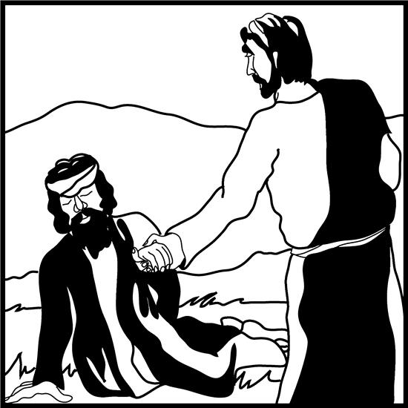

**Twenty-second Sunday after Pentecost**

**October 24th, 2021 9:30 am**

**Zoom Worship Service**

**ZOOM 706 565 767, Passcode 767**

**SHEPHERD OF THE HILLS LUTHERAN CHURCH**

**4887 Valleydale Road, Birmingham, AL 35242**

**(205) 995-9673** **www.sothl.org**

We pray that our time together will be an inspiration to all. Our order of worship is Setting Four from the Evangelical Lutheran Worship (ELW red). Our order of worship is printed in its entirety below. **Congregation** responses are indicated in **bold** print, P: Pastor, **C: Congregation**

|  |  |
| --- | --- |
| **SOTH hills**  **Welcome to**  **Shepherd of the Hills**  **Lutheran Church**  *“A Place to Call Home”* | ***Our Mission Statement***  *Shepherd of the Hills Lutheran Church seeks to demonstrate God’s grace, to learn and grow in the Christian faith, and to serve with humility.*  ***Our Welcoming Statement***  *As an inclusive congregation, we welcome all into God’s love and grace without regard to:*  *Ability * Age * Beliefs * Culture * Ethnicity * Gender Identity * Income * Language * Life Circumstances * Marital Status * Race * Sexual Orientation*  ***As God’s grace welcomes all, we are united in Christ*** |
| **Thank you for worshiping with us today. If you need assistance following the order of worship, feel free to ask your neighbor for help. May this time of worship encourage and strengthen you for the week ahead. We hope you’ll worship with us again.**  **Pastor**: Carolyn Hayford (803) 606-6683 **Secretary**: Liz Satterfield (205) 995-9673  **Musician**: Ann Jones (205) 902-2444 **Council President**: Larry Smith (205) 988-6449  **Soloist**: Eric Campbell | |
| **Serving us today in Worship:**  **Worship Assistant:** Marie Prine **Zoomster/AV**: Peggy Huckabaa  **Reader**: Dorothy McMullin **Head Zoom Usher**: Susan Pritchett  **Children’s Message:** Carla Crowder **Music:**  Ann Jones  **Soloist:** Eric Campbell  Please check out our new and improved website: www.sothl.org.  Note that pictures taken at various church events and services are posted on both our website and our Facebook page. If you do not want your picture to appear on our page or on the web site for any reason, please alert the church office at office@sothl.org or 205-995-9673 so that your request can be honored. | |

**Order of Worship**

**Twenty-second Sunday after Pentecost**

October 24th, 2021

**WELCOME AND ANNOUNCEMENTS**

**MOVED TO PHASE 2 OF OUR PHASED TRANSITION COVID-19 PLAN**

**PUMPKIN CARVING** Today at SOTHL at 11:30AM. Please bring a pumpkin and a large knife

**CONGREGATIONAL MEETING** November 7th through Zoom, following the worship service

**FIREHOUSE SHELTER** October 27th at 6:00PM

**MY YOUNG FRIENDS!!** Bartimaeus Sees! Mark 10:46-52

**PRELUDE** Agape by Jim Tidwell

**CONFESSION AND FORGIVENESS**

P: Blessed be the holy Trinity, ☩ one God, full of compassion and mercy, abounding in steadfast love.

**C: Amen**

A: Trusting God’s promise of forgiveness, let us confess our sin against God and one another.

*Silence for reflection and self-examination*

A: Eternal God our creator,

**C: In you we live and move and have our being. Look upon us, your children, the work of your hands. Forgive us all our offenses, and cleanse us from proud thoughts and empty desires. By your grace draw us near to you, our refuge and our strength; through Jesus Christ our Lord.**

**Amen.**

P: Since we are justified by faith, we have peace with God through our Lord Jesus Christ. God’s love has been poured into our hearts through the Holy Spirit given to us. In the mercy of almighty God, Christ died for us while we still were sinners; and for his sake, God ☩ forgives you all your sins.

**C: Amen.**

**GATHERING HYMN** ELW 673 God, Whose Almighty Word: all verses

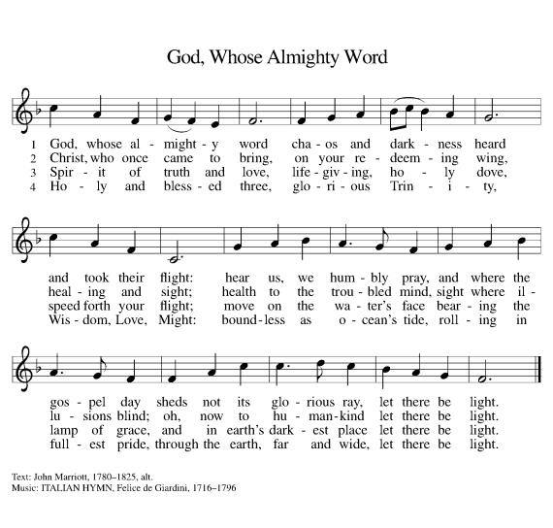





**Greeting**

P: The grace of our Lord Jesus Christ, the love of God, and the communion of the Holy Spirit be with you all.

**C: And also with you**

**KYRIE**

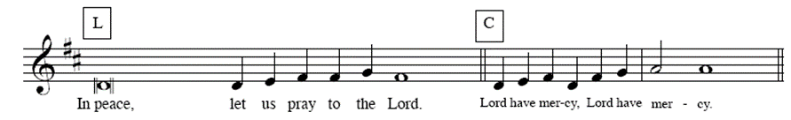

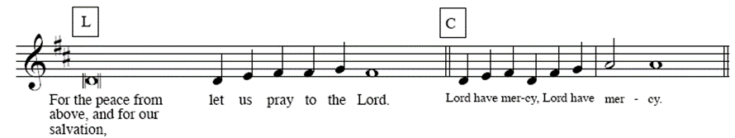

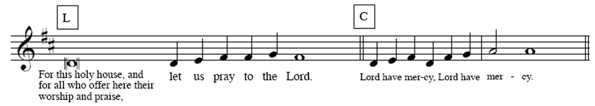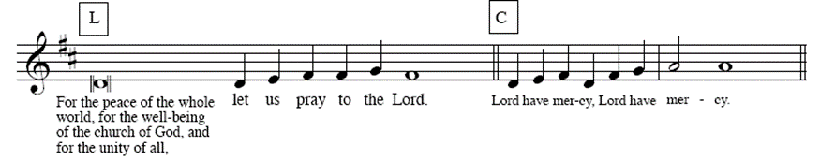

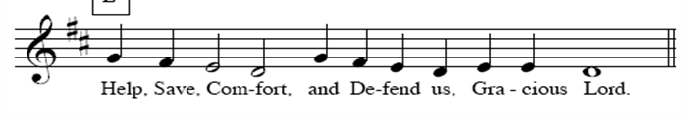

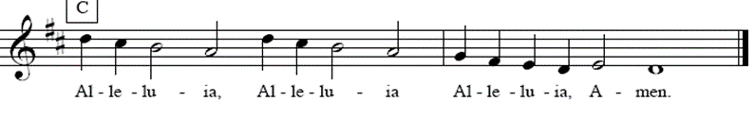

**Prayer of the Day**

A: Let us pray.

A: Eternal light, shine in our hearts. Eternal wisdom, scatter the darkness of our ignorance. Eternal compassion, have mercy on us. Turn us to seek your face, and enable us to reflect your goodness, through Jesus Christ, our Savior and Lord.

**C:** **Amen.**

**CHILDREN’S MESSAGE**

**THE FIRST READING: Jeremiah 31:7-9**

*This passage speaks not only of the southern kingdom, Judah, and its homecoming from exile in Babylon, but also of the northern kingdom (“Israel” or “Ephraim”) and its restoration. The northern tribes of Israel had been lost in exile to Assyria more than a century before Jeremiah prophesied.*

7Thus says the Lord:  
 Sing aloud with gladness for Jacob,  
  and raise shouts for the chief of the nations;  
 proclaim, give praise, and say,  
  “Save, O Lord, your people,  
  the remnant of Israel.”  
 8See, I am going to bring them from the land of the north,  
  and gather them from the farthest parts of the earth,  
 among them the blind and the lame,  
  those with child and those in labor, together;  
  a great company, they shall return here.  
 9With weeping they shall come,  
  and with consolations I will lead them back,  
 I will let them walk by brooks of water,  
  in a straight path in which they shall not stumble;  
 for I have become a father to Israel,  
  and Ephraim is my firstborn.

R: The word of the Lord.

**C: Thanks be to God.**

**THE PSALM** *Please* *read Psalm 126 responsively.*

1When the Lord restored the fortunes of Zion, then were we like those who dream.

2**Then was our mouth filled with laughter, and our tongue with shouts of joy.** **Then they said among the nations, “The Lord has done great things for them.”** 

3The Lord has done great things for us, and we are glad indeed.

4**Restore our fortunes, O Lord,** **like the watercourses of the Negeb.**

5Those who sowed with tears will reap with songs of joy.

6**Those who go out weeping, carrying the seed,** **will come again with joy, shouldering their sheaves.** 

**Second Reading: Hebrews 7:23-28**

*Human priests of old offered sacrifice for their own sins and served only until their death. In contrast, Jesus is God’s Son, the holy, sinless, resurrected high priest. Death did not terminate his priestly service, but through his death he has interceded for our sins.*

23The former priests were many in number, because they were prevented by death from continuing in office; 24but he holds his priesthood permanently, because he continues forever. 25Consequently he is able for all time to save those who approach God through him, since he always lives to make intercession for them.

26For it was fitting that we should have such a high priest, holy, blameless, undefiled, separated from sinners, and exalted above the heavens. 27Unlike the other high priests, he has no need to offer sacrifices day after day, first for his own sins, and then for those of the people; this he did once for all when he offered himself. 28For the law appoints as high priests those who are subject to weakness, but the word of the oath, which came later than the law, appoints a Son who has been made perfect forever.

R: The word of the Lord.

**C: Thanks be to God.**

**GOSPEL ACCLAMATION**



### THE HOLY GOSPEL Mark 10:46-52

### C: Glory to you, O Lord.

*Bartimaeus comes to Jesus with faith, asking that he might see again. Recognizing Jesus’ identity, Bartimaeus is the first person to call him “Son of David” in the Gospel of Mark.*

46As [Jesus] and his disciples and a large crowd were leaving Jericho, Bartimaeus son of Timaeus, a blind beggar, was sitting by the roadside. 47When he heard that it was Jesus of Nazareth, he began to shout out and say, “Jesus, Son of David, have mercy on me!” 48Many sternly ordered him to be quiet, but he cried out even more loudly, “Son of David, have mercy on me!” 49Jesus stood still and said, “Call him here.” And they called the blind man, saying to him, “Take heart; get up, he is calling you.” 50So throwing off his cloak, he sprang up and came to Jesus. 51Then Jesus said to him, “What do you want me to do for you?” The blind man said to him, “My teacher, let me see again.” 52Jesus said to him, “Go; your faith has made you well.” Immediately he regained his sight and followed him on the way.

P: The gospel of the Lord.

**C: Praise to you, O Christ.**

**THE MESSAGE**

**THE HYMN OF THE DAY** ELW 722 O Christ, Your Heart, Compassionate: verses 1,2,3

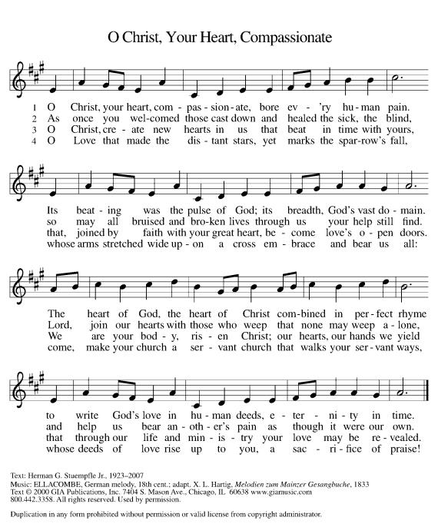







**THE APOSTLES CREED** ELW 105

A: Let us confess together our faith using the words of the Apostle’s Creed

**C: I believe in God, the Father almighty, creator of heaven and earth.**

**I believe in Jesus Christ, God's only Son, our Lord, who was conceived by the Holy Spirit, born of the virgin Mary, suffered under Pontius Pilate, was crucified, died, and was buried; he descended to the dead.**

**On the third day he rose again; he ascended into heaven, he is seated at the right hand of the Father, and he will come to judge the living and the dead.**

**I believe in the Holy Spirit, the holy catholic church, the communion of saints, the forgiveness of sins, the resurrection of the body, and the life everlasting. Amen.**

**THE PRAYERS OF THE CHURCH**

A**:** Hear us, O God.

**C: Your Mercy is great.**

*.*

**TITHES AND OFFERINGS**

**Offering Music** ELW 690We Raise Our Hands to You, O Lord verses 1,3,5

A: The work and mission of the church continues no matter how we gather, in person, electronically, wherever two or more are gathered together in His name. Lord on this day, we bring our tithes and offerings, giving from the abundance that you have given us.

**THE OFFERING PRAYER**

A: Let us pray together,

**C:** **Merciful God, you open wide your hand and satisfy the need of every living thing. You have set this feast before us. Open our hands to receive it. Open our hearts to embrace it. Open our lives to live it. We pray this through Christ our Lord. Amen.**

**THANKSGIVING FOR THE WORD**

P: Send your Spirit of truth, O God; Rekindle your gifts within us: renew our faith, increase our hope, and deepen our love, for the sake of a world in need. Faithful to your Word, O God, draw near to all who call on you; through Jesus Christ, our savior and Lord, to whom, with you and the Holy Spirit, be honor and glory forever.

**C: Amen**

**THE LORD’S PRAYER** (Please speak whichever version, in whatever language, you prefer.)

P: Gathered into one by the Holy Spirit, let us pray as Jesus taught us.

**C: Our Father in heaven, hallowed be your name, your kingdom come, your will be done, on earth as in heaven. Give us today our daily bread. Forgive us our sins as we forgive those who sin against us. Save us from the time of trial and deliver us from evil. For the kingdom, the power, and the glory are yours, now and forever. Amen.**

**BLESSING**

P: People of God, you are Christ’s body, bringing new life to a suffering world.

The holy Trinity, ☩ one God, bless you now and forever.

**C: Amen.**

**SENDING HYMN** ELW546 To Be Your Presence: verses 1,2,4

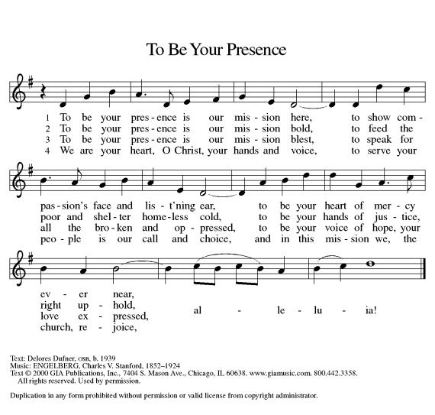

**DISMISSAL**

A: Go in peace. Serve the Lord.

**C: Thanks be to God.**

**POSTLUDE** Italian Hymn arr: Stan Pethel

Liturgy from Sundays and Seasons.com. Copyright 2021 Augsburg Fortress. All rights reserved. Reprinted by permission under Augsburg Fortress Liturgies Annual License. . ID #: SAS008054

**Next Week’s Lesson**

**THE FIRST READING:** Jeremiah 31:31-34

**PSALM:** Psalm 46

**THE SECOND READING:** Romans 3:19-28

**THE GOSPEL:** John 8:31-36

**Intercessory Prayer**

We are a praying community; believing in the value of prayer.  We ask that you keep the congregation, our community, and all those on the prayer list insert in your prayers during the week. Prayer request cards can be found in the Narthex or in the back of the hymnal.

Please utilize the Intercessory Prayer insert during your prayers this week.

Worship Servants for **October 31:**

**Worship Assistant**: Susan Pritchett **Zoomster/AV:** Peggy Huckabaa

**Reader**: Dede Conover-Blankenship **Head Zoom Usher:** Marie Prine

**Children’s Message**: Gene Meyers **Music**: Ann Jones

**Soloist**: Eric Campbell

**THIS WEEK AT SOTH**

**Sunday 10/24** 9:30 am          E-Worship **Meeting ID** 706 565 767,

**Pass code** 767

10 Minutes Adult Forum

after service

**Monday** 7:00 pm AA – New Hope, Alanon

**Tuesday** 7:00 pm          Zoom Social**/**Covid19 Q&A **Meeting ID** 706 565 767, **Pass code** 767

**Wednesday** 9:30 am Wednesday Bible Study **Meeting ID** 175 995 438

6:00 pm Firehouse Shelter

6:30 pm Prayer, Meditation and **Meeting ID** 706 565 767

Conversation **Pass code** 767

**Thursday**

**Friday**

**Saturday** 6:30 pm AA – New Hope

**OFFERING DONATIONS** – Each month, 2% of our General Fund offerings are donated to a local or ELCA ministry.  The 2% of these offerings in October will be donated to Habitat for Humanity

**ANNOUNCEMENTS**

**CONGREGATIONAL MEETING** A meeting of this congregation to adopt a congregational budget will be held Sunday, November 7th following the worship service.

**COUNCIL UPDATE** **10/15** Moved to Phase 2 of our phased transition plan for covid-19. No PowerPoints during service. Please use your bulletins. Phase 2 includes outdoor worship, outdoor meetings and SMALL (up to 20) indoor meetings with social distancing and masks.  **FIREHOUSE SHELTER** SOTHL will be going to the Firehouse Shelter on Wednesday October 27th at 6:00 serve dinner to the men at the shelter. It is a wonderful experience and we would love for you to join us!  Please contact Jeanne Trammell if you would like to go or have any questions. [JTram1985@gmail.com](mailto:JTram1985@gmail.com)  Thank you!

**MY YOUNG FRIENDS!!**  Bartimaeus Sees! Mark 10:46-52

**FOOD PANTRY** For families in times of need, having food available can make a big difference. There are many ways to help and get involved in making a difference for those who are struggling. Please consider either creating bags using the recipes on the website or create your own recipes and share them with us so we can put it in the rotation. If you would prefer, you can donate money instead to evangelism / outreach either on line (https://secure.myvanco.com/YM4V/home) or by check.  Thank you for your generosity.

**COVID-19 Notifiers**: The COVID Task Force has established the following process to ensure we do not need to modify our current procedures and to help identify a potential cluster early: Anyone who attends a church even (even parking lot ones) or has been in the church building for any reason, and tests positive for COVID within 2 weeks of being here, is asked to contact one of the volunteers on this list below. Your name will be kept completely confidential. Thank you! Jared Brunswick, 205-531-5428, jrdbrunswick@yahoo.com; Erica Bjornstad, 443-717-0065, ericaecuador@yahoo.com; Susan Pritchett, 205-602-1282, sspritch@bellsouth.net.

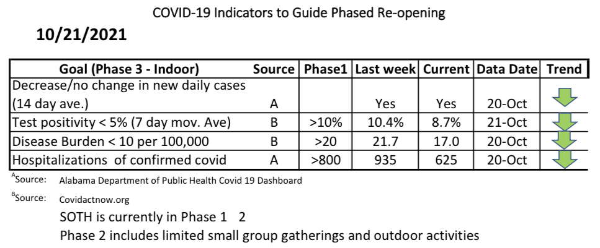

**WORSHIP MUSIC** - Wondering about the beautiful music you hear in our worship service? It’s Eric Campbell’s voice. The piano is played by Ann Jones. We appreciate them sharing their gifts to the glory of God.

**ZOOM Meetings**

**SUNDAY – E - WORSHIP:**

Sundays at 9:30 am. Consider signing on early to catch up with friends and family.  The room is open at 9:00 am. Click on the link below:

https://us02web.zoom.us/j/706565767?pwd=MjJMbEIyM2pNMkkvaHJWNW1YSHU0UT09

Or call this number:  1-312-626-6799

Enter Meeting ID 706 565 767, Passcode 767

**SUNDAY – SPANISH PRAYER MINISTRY:**

Led by Pastor Ed Cortes – 1st Sunday in the Month at 2:30pm

Click this link: https://zoom.us/j/88295986939

Or call this number: 1-646-558-8656 Enter Meeting ID: 882 959 -6939

**MONDAY – SOTH COVID TASK FORCE:**

Mondays at 7:00PM – Based on circumstance

Click this link:

https://us02web.zoom.us/j/706565767?pwd=MjJMbEIyM2pNMkkvaHJWNW1YSHU0UT09

Or Call this number:  1-312-626-6799 Enter Meeting ID 706 565 767, Passcode 767

**TUESDAY – NIGHT ZOOM SOCIAL:**

A question and answer session with Erica Bjornstad, pediatrician epidemiologist, regarding current status of COVID-19 which has morphed into a Friendly support group. If you do have any questions about COVID-19 or just want to check in with some friendly folks. Tuesdays at 7:00 pm

Click this link:

https://us02web.zoom.us/j/706565767?pwd=MjJMbEIyM2pNMkkvaHJWNW1YSHU0UT09

Or call this number: 1-312-626-6799 Enter meeting ID: 706 565 767, Passcode 767

**WEDNESDAY – BIBLE STUDY:**

Wednesday at 9:30am

Click this link: https://zoom.us/j/175995438

Or call this number: 1-312-626-6799 Enter Meeting ID: 175 995 438

**WEDNESDAY – LYDIA CIRCLE:**

All women are welcome to join. Normally first Wednesday of the month at 9:30 am

Click this link:   https://us02web.zoom.us/j/524874986

Or call this number: 1-312-626-6799 Enter meeting ID:  524 874 986

**WEDNESDAY PRAYER, MEDITATION & CONVERSATION**

We view films and videos and talk about topics of interest. Join Pastor Carolyn and your church friends to talk openly in a safe space. Wednesday at 6:30 p.m. – 8:00 pm

Click this link:  

https://us02web.zoom.us/j/706565767?pwd=MjJMbEIyM2pNMkkvaHJWNW1YSHU0UT09

Or call this number: 1-312-626-6799 Enter Meeting ID 706 565 767, Passcode 767

**2021 CHURCH LEADERSHIP**

**COUNCIL OFFICERS**

Larry Smith, President

Bob Oster, Vice President

Brooke Breland, Secretary

**COUNCIL MEMBERS**

Dede Conover-Blankenship, Fellowship Committee Liaison

Will Breland, Outreach Committee Liaison

Bob Peters, Facilities Committee Liaison

Marie Prine, Worship Committee Liaison

Tracy Teague, Learning Committee Liaison

OPEN Stewardship Committee Liaison

**COMMITTEE CHAIRS**

John Boettner, Worship

Rachel Brunswick, Learning

Mike Huckabaa, Facilities

Susan Pritchett, Fellowship

Dennis Steul, Stewardship

Jeanne Trammell Outreach/Witness (Temporarily contact Susan Pritchett)

**Children’s Worship Bulletin**





*Word Search Puzzle*

*Coloring Page*

