

**Eighteenth Sunday after Pentecost**

**September 26th, 2021  9:30 am**

**Worship Service**

**ZOOM 706 565 767, Passcode 767**

**SHEPHERD OF THE HILLS LUTHERAN CHURCH**

**4887 Valleydale Road, Birmingham, AL 35242**

**(205) 995-9673** **www.sothl.org**

We pray that our time together will be an inspiration to all. Our order of worship is Setting Three from the Evangelical Lutheran Worship (ELW red). Our order of worship is printed in its entirety below. **Congregation** responses are indicated in **bold** print, P: Pastor, **C: Congregation**

|  |  |
| --- | --- |
| **SOTH hills**  **Welcome to**  **Shepherd of the Hills**  **Lutheran Church**  *“A Place to Call Home”* | ***Our Mission Statement***  *Shepherd of the Hills Lutheran Church seeks to demonstrate God’s grace, to learn and grow in the Christian faith, and to serve with humility.*  ***Our Welcoming Statement***  *As an inclusive congregation, we welcome all into God’s love and grace without regard to:*  *Ability * Age * Beliefs * Culture * Ethnicity * Gender Identity * Income * Language * Life Circumstances * Marital Status * Race * Sexual Orientation*  ***As God’s grace welcomes all, we are united in Christ*** |
| **Thank you for worshiping with us today. If you need assistance following the order of worship, feel free to ask your neighbor for help. May this time of worship encourage and strengthen you for the week ahead. We hope you’ll worship with us again.**  **Pastor**: Carolyn Hayford (803) 606-6683 **Secretary**: Liz Satterfield (205) 995-9673  **Musician**: Ann Jones (205) 902-2444 **Council President**: Larry Smith (205) 988-6449  **Soloist**: Eric Campbell | |
| **Serving us today in Worship:**  **Worship Assistant:** Bob Oster **Zoomster**: Peggy Huckabaa  **Reader**: Dorothy McMullin **Head Zoom Usher**: Marie Prine  **Children’s Message:** Kim Boettner **Music:**  Ann Jones  **Soloist:** Eric Campbell  Please check out our new and improved website: www.sothl.org.  Note that pictures taken at various church events and services are posted on both our website and our Facebook page. If you do not want your picture to appear on our page or on the web site for any reason, please alert the church office at office@sothl.org or 205-995-9673 so that your request can be honored. | |

**Order of Worship**

**Eighteenth Sunday after Pentecost**

September 26th, 2021

**WELCOME AND ANNOUNCEMENTS**

**BLOOD DRIVE** Red Cross blood drive is being held 10/13/21 at SOTHL from 1-6 PM Please sign up at https://www.redcross.org/give-blood.html. Also need volunteers to staff the event. Please reach out to Pastor, the office or Susan Pritchett to sign up.

**NEW AV EQUIPMENT** - notice anything different? Today is our first trial run. We are excited. Remember, Grace Abounds. Like what you see? Come join us in learning how to operate it.

**PRELUDE**

**CONFESSION AND FORGIVENESS**

P: Blessed be the holy Trinity, ☩ one God, full of compassion and mercy, abounding in steadfast love.

**C: Amen**

A: Trusting God’s promise of forgiveness, let us confess our sin against God and one another.

*Silence for reflection and self-examination*

A: Eternal God our creator,

**C: In you we live and move and have our being. Look upon us, your children, the work of your hands. Forgive us all our offenses, and cleanse us from proud thoughts and empty desires. By your grace draw us near to you, our refuge and our strength; through Jesus Christ our Lord.**

**Amen.**

P: Since we are justified by faith, we have peace with God through our Lord Jesus Christ. God’s love has been poured into our hearts through the Holy Spirit given to us. In the mercy of almighty God, Christ died for us while we still were sinners; and for his sake, God ☩ forgives you all your sins.

**C: Amen.**

**GATHERING HYMN** ELW 636 How Small Our Span of Life



**Greeting**

P: The grace of our Lord Jesus Christ, the love of God, and the communion of the Holy Spirit be with you all.

**C: And also with you**

**KYRIE**

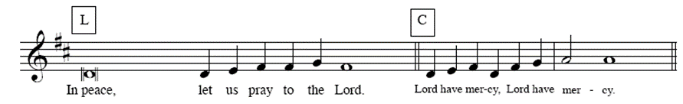

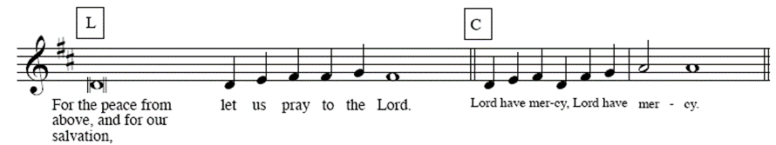

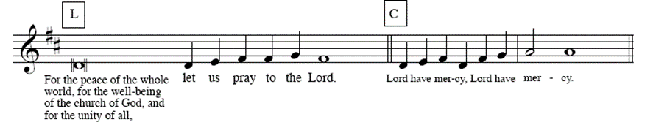

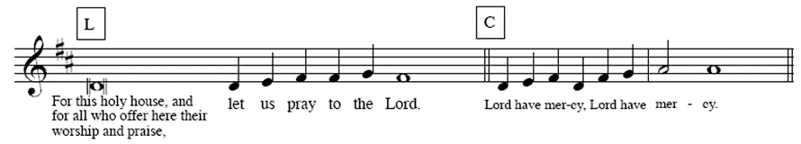

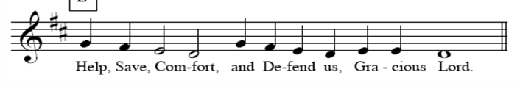

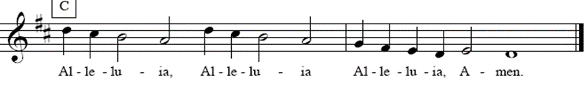

**Prayer of the Day**

A: Let us pray.

A: Generous God, your Son gave his life that we might come to peace with you. Give us a share of your Spirit, and in all we do empower us to bear the name of Jesus Christ, our Savior and Lord.

**C:** **Amen.**

**CHILDREN’S MESSAGE**

**THE FIRST READING: Numbers 11:4-6, 10-16, 24-29**

*What constitutes legitimate need and legitimate leadership is the focus of this reading. God provides manna in the wilderness, yet the people crave meat. What is truly needful? God bestows the spirit on seventy elders, yet two men not designated as leaders prophesy in the power of God’s spirit. What constitutes real leadership?*

4The rabble among them had a strong craving; and the Israelites also wept again, and said, “If only we had meat to eat! 5We remember the fish we used to eat in Egypt for nothing, the cucumbers, the melons, the leeks, the onions, and the garlic; 6but now our strength is dried up, and there is nothing at all but this manna to look at.”  
  10Moses heard the people weeping throughout their families, all at the entrances of their tents. Then the Lord became very angry, and Moses was displeased. 11So Moses said to the Lord, “Why have you treated your servant so badly? Why have I not found favor in your sight, that you lay the burden of all this people on me? 12Did I conceive all this people? Did I give birth to them, that you should say to me, ‘Carry them in your bosom, as a nurse carries a sucking child, to the land that you promised on oath to their ancestors’? 13Where am I to get meat to give to all this people? For they come weeping to me and say, ‘Give us meat to eat!’ 14I am not able to carry all this people alone, for they are too heavy for me. 15If this is the way you are going to treat me, put me to death at once—if I have found favor in your sight—and do not let me see my misery.”  
  16So the Lord said to Moses, “Gather for me seventy of the elders of Israel, whom you know to be the elders of the people and officers over them; bring them to the tent of meeting, and have them take their place there with you.”  
  24So Moses went out and told the people the words of the Lord; and he gathered seventy elders of the people, and placed them all around the tent. 25Then the Lord came down in the cloud and spoke to him, and took some of the spirit that was on him and put it on the seventy elders; and when the spirit rested upon them, they prophesied. But they did not do so again.  
  26Two men remained in the camp, one named Eldad, and the other named Medad, and the spirit rested on them; they were among those registered, but they had not gone out to the tent, and so they prophesied in the camp. 27And a young man ran and told Moses, “Eldad and Medad are prophesying in the camp.” 28And Joshua son of Nun, the assistant of Moses, one of his chosen men, said, “My lord Moses, stop them!” 29But Moses said to him, “Are you jealous for my sake? Would that all the Lord‘s people were prophets, and that the Lord would put his spirit on them!”

R: The word of the Lord.

**C: Thanks be to God.**

**THE PSALM** *Read Psalm 19 responsively.*

7The teaching of the Lord is perfect and revives the soul; the testimony of the Lord is sure and gives wisdom to the simple.

 8**The statutes of the Lord are just and rejoice the heart; the commandment of the Lord is clear and gives light to the eyes.**

 9The fear of the Lord is clean and endures forever; the judgments of the Lord are true and righteous altogether.

 10**More to be desired are they than gold, more than much fine gold, sweeter far than honey, than honey in the comb.**

 11By them also is your servant enlightened, and in keeping them there is great reward.

 12**Who can detect one’s own offenses? Cleanse me from my secret faults.**

 13Above all, keep your servant from presumptuous sins; let them not get dominion over me; then shall I be whole and sound, and innocent of a great offense.

 14**Let the words of my mouth and the meditation of my heart be acceptable in your sight, O Lord, my strength and my redeemer.**

**Second Reading: James 5:13-20**

*Marks of the Christian community include praying for those who are sick and in need, celebrating with those in good health, restoring those who have strayed, confessing sins to one another, and offering forgiveness to each other.*

13Are any among you suffering? They should pray. Are any cheerful? They should sing songs of praise. 14Are any among you sick? They should call for the elders of the church and have them pray over them, anointing them with oil in the name of the Lord. 15The prayer of faith will save the sick, and the Lord will raise them up; and anyone who has committed sins will be forgiven. 16Therefore confess your sins to one another, and pray for one another, so that you may be healed. The prayer of the righteous is powerful and effective. 17Elijah was a human being like us, and he prayed fervently that it might not rain, and for three years and six months it did not rain on the earth. 18Then he prayed again, and the heaven gave rain and the earth yielded its harvest.  
  19My brothers and sisters, if anyone among you wanders from the truth and is brought back by another, 20you should know that whoever brings back a sinner from wandering will save the sinner’s soul from death and will cover a multitude of sins.

R: The word of the Lord.

**C: Thanks be to God.**

**GOSPEL ACCLAMATION**



### THE HOLY GOSPEL Mark 9:38-50

### C: Glory to you, O Lord.

*On the way to Jerusalem, Jesus teaches his disciples about ministry that involves service and sacrifice. His disciples are slow to realize that these words apply to them as well as to others.*

38John said to [Jesus,] “Teacher, we saw someone casting out demons in your name, and we tried to stop him, because he was not following us.” 39But Jesus said, “Do not stop him; for no one who does a deed of power in my name will be able soon afterward to speak evil of me. 40Whoever is not against us is for us. 41For truly I tell you, whoever gives you a cup of water to drink because you bear the name of Christ will by no means lose the reward.  
  42“If any of you put a stumbling block before one of these little ones who believe in me, it would be better for you if a great millstone were hung around your neck and you were thrown into the sea. 43If your hand causes you to stumble, cut it off; it is better for you to enter life maimed than to have two hands and to go to hell, to the unquenchable fire. 45And if your foot causes you to stumble, cut it off; it is better for you to enter life lame than to have two feet and to be thrown into hell. 47And if your eye causes you to stumble, tear it out; it is better for you to enter the kingdom of God with one eye than to have two eyes and to be thrown into hell, 48where their worm never dies, and the fire is never quenched.  
  49“For everyone will be salted with fire. 50Salt is good; but if salt has lost its saltiness, how can you season it? Have salt in yourselves, and be at peace with one another.”

P: The gospel of the Lord.

**C: Praise to you, O Christ.**

**THE SERMON**

**THE HYMN OF THE DAY** ELW 712 Lord, Whose Love in Humble Service **V 1,2 &4**

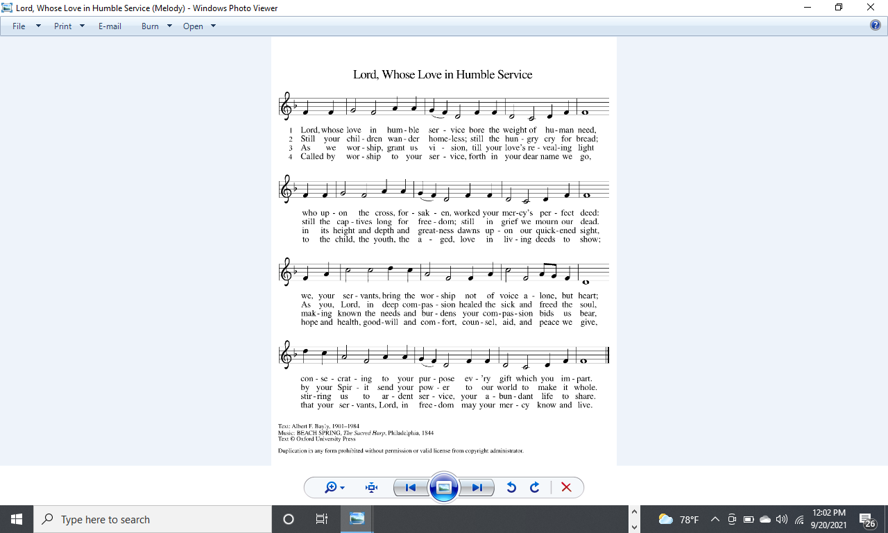



**THE APOSTLES CREED** ELW 105

A: Let us confess together our faith using the words of the Apostle’s Creed

**C: I believe in God, the Father almighty, creator of heaven and earth.**

**I believe in Jesus Christ, God's only Son, our Lord, who was conceived by the Holy Spirit, born of the virgin Mary, suffered under Pontius Pilate, was crucified, died, and was buried; he descended to the dead.**

**On the third day he rose again; he ascended into heaven, he is seated at the right hand of the Father, and he will come to judge the living and the dead.**

**I believe in the Holy Spirit, the holy catholic church, the communion of saints, the forgiveness of sins, the resurrection of the body, and the life everlasting. Amen.**

**THE PRAYERS OF THE CHURCH**

A**:** Lord, in your mercy

**C: hear our prayer.**

*.*

**TITHES AND OFFERINGS**

A: The work and mission of the church continues no matter how we gather, in person, electronically, wherever two or more are gathered together in His name. Lord on this day, we bring our tithes and offerings, giving from the abundance that you have given us.

**THE OFFERING PRAYER**

A: Let us pray together,

**C:** **Merciful God, you open wide your hand and satisfy the need of every living thing. You have set this feast before us. Open our hands to receive it. Open our hearts to embrace it. Open our lives to live it. We pray this through Christ our Lord. Amen.**

**THANKSGIVING FOR THE WORD**

P: Send your Spirit of truth, O God; Rekindle your gifts within us: renew our faith, increase our hope, and deepen our love, for the sake of a world in need. Faithful to your Word, O God, draw near to all who call on you; through Jesus Christ, our savior and Lord, to whom, with you and the Holy Spirit, be honor and glory forever.

**C: Amen**

**THE LORD’S PRAYER** (Please speak whichever version, in whatever language, you prefer.)

P: Gathered into one by the Holy Spirit, let us pray as Jesus taught us.

**C: Our Father in heaven, hallowed be your name, your kingdom come, your will be done, on earth as in heaven. Give us today our daily bread. Forgive us our sins as we forgive those who sin against us. Save us from the time of trial and deliver us from evil. For the kingdom, the power, and the glory are yours, now and forever. Amen.**

**BLESSING**

P: People of God, you are Christ’s body, bringing new life to a suffering world.

The holy Trinity, ☩ one God, bless you now and forever.

**C: Amen.**

**SENDING HYMN** ELW497 Strengthen For Service, Lord

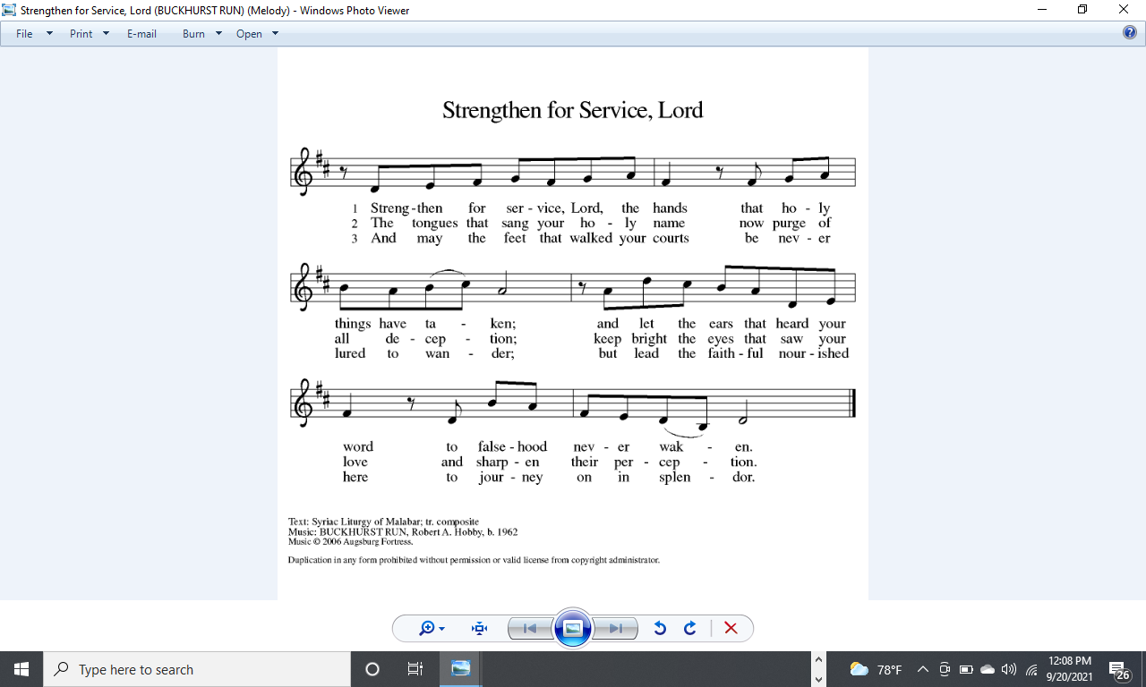

**DISMISSAL**

A: Go in peace. The living Word dwells in you.

**C: Thanks be to God.**

**POSTLUDE**

Liturgy from Sundays and Seasons.com. Copyright 2021 Augsburg Fortress. All rights reserved. Reprinted by permission under Augsburg Fortress Liturgies Annual License. . ID #: SAS008054

**Next Week’s Lesson**

**THE FIRST READING:** Genesis 2:18-24

**PSALM:** Psalm 8

**THE SECOND READING:** Hebrews 1:1-4; 2:5-12

**THE GOSPEL:** Mark 10:2-16

**Intercessory Prayer**

We are a praying community; believing in the value of prayer.  We ask that you keep the congregation, our community, and all those on the prayer list insert in your prayers during the week. Prayer request cards can be found in the Narthex or in the back of the hymnal.

Please utilize the Intercessory Prayer insert during your prayers this week.

Worship Servants for **October 3:**

**Worship Assistant**: Kim Boettner **Zoomster**: Peggy Huckabaa

**Reader**: Sonya Reynolds **Head Zoom Usher:** Carrie Peters

**Children’s Message**: Gene Myers **Music**: Ann Jones

**Soloist**: Eric Campbell

**THIS WEEK AT SOTH**

**Sunday** 9:30 am          E-Worship **Meeting ID** 706 565 767,

**9/26** **Pass code** 767

10 minutes Adult Forum

following service

**Monday**

7:00 pm AA – New Hope, Alanon

**Tuesday** 7:00 pm          Zoom Social**/**Covid19 Q&A **Meeting ID** 706 565 767, **Pass code** 767

**Wednesday** 9:30 am Wednesday Bible Study **Meeting ID** 175 995 438

6:30 pm Prayer, Meditation and **Meeting ID** 706 565 767

Conversation **Pass code** 767

**Thursday**

**Friday**

**Saturday** 6:30 pm AA – New Hope

**ANNOUNCEMENTS**

**MY YOUNG FRIENDS!!**  Today's Bible story is "Share God's Love" on page 326 in your *Spark Story Bible*.  If you don't have a *Spark Story Bible* you can read the story in any Bible in Mark 9:28-50.  How do you share God's LOVE?

**FOOD PANTRY** Demand continues to be steady. For families struggling, extra food means all the difference in their lives.  You can join in this vital ministry where people feel loved and valued and their bellies are filled. Please consider either creating bags using the recipes on the website or create your own recipes and share them with us so we can put it in the rotation. If you would prefer, you can donate money instead to evangelism / outreach either on line (https://secure.myvanco.com/YM4V/home) or by check.  Thank you for your generosity.

**BLOOD DRIVE** Red cross blood drive is being held 10/13/21 at SOTHL from 1-6 PM Please sign up at https://www.redcross.org/give-blood.html. Also need volunteers to staff the event. Please reach out to Pastor, the office or Susan Pritchett to sign up.

**NEW AV –** Now is the time to step up and learn the new equipment together. Grace abounds. Come join the Worship team. We have audio, Zoomster, readers, children’s messages & ushers. We worship and learn together.

**OPPORTUNITY FOR A LIFE CHANGING EXPERIENCE** – ELCA Southeastern Synod is sponsoring a trip – Cristo Rey Border Immersion Program at El Paso, Texas and Juarez, Mexico. March 12-19, 2022. Limited availability; only 14 participants. To find out more, go to <https://enconjunto.weebly.com/2022-bie.html>. Do not need to know Spanish.

**INTERESTED IN ADVOCACY?** The Southeastern Synod wants to know what who is interested in what issues and bring people together. Answer the survey by using this link**:**

[**https://se-reg.brtapp.com/AdvocacySurvey54**](https://se-reg.brtapp.com/AdvocacySurvey54)

**COVID-19 Notifiers**: The COVID Task Force has established the following process to ensure we do not need to modify our current procedures and to help identify a potential cluster early: Anyone who attends a church even (even parking lot ones) or has been in the church building for any reason, and tests positive for COVID within 2 weeks of being here, is asked to contact one of the volunteers on this list below. Your name will be kept completely confidential. Thank you! Jared Brunswick, 205-531-5428, jrdbrunswick@yahoo.com; Erica Bjornstad, 443-717-0065, ericaecuador@yahoo.com; Susan Pritchett, 205-602-1282, sspritch@bellsouth.net.

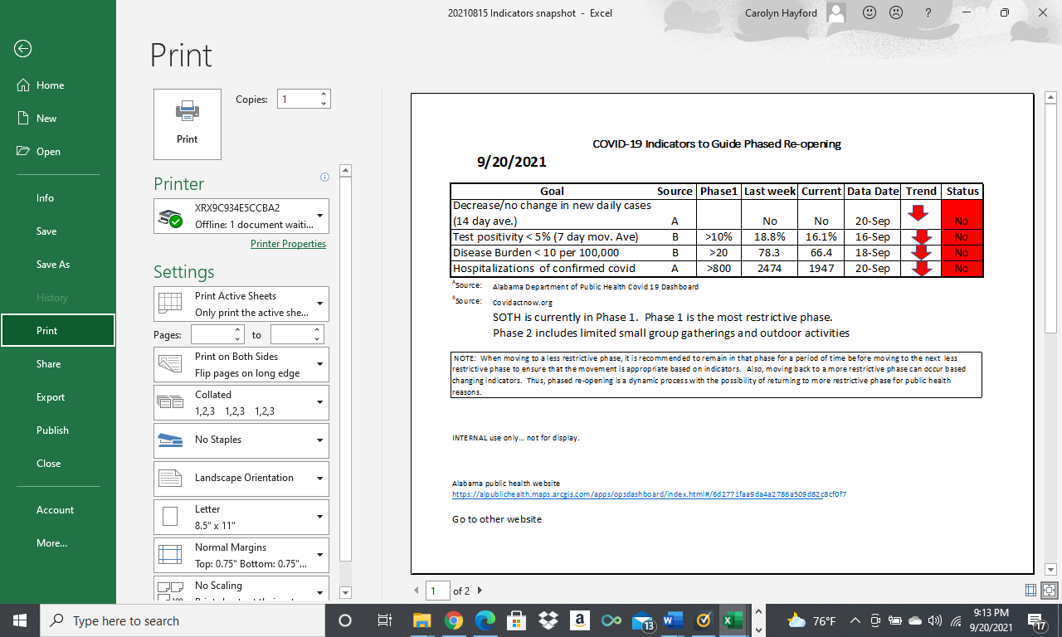

**ZOOM Meetings**

**SUNDAY – E - WORSHIP:**

Sundays at 9:30 am. Consider signing on early to catch up with friends and family.  The room is open at 9:00 am. Click on the link below:

https://us02web.zoom.us/j/706565767?pwd=MjJMbEIyM2pNMkkvaHJWNW1YSHU0UT09

Or call this number:  1-312-626-6799

Enter Meeting ID 706 565 767, Passcode 767

**SUNDAY – SPANISH PRAYER MINISTRY:**

Led by Pastor Ed Cortes – 1st Sunday in the Month at 2:30pm

Click this link: https://zoom.us/j/88295986939

Or call this number: 1-646-558-8656 Enter Meeting ID: 882 959 -6939

**MONDAY – SOTH COVID TASK FORCE:**

Mondays at 7:00PM – Based on circumstance

Click this link:

https://us02web.zoom.us/j/706565767?pwd=MjJMbEIyM2pNMkkvaHJWNW1YSHU0UT09

Or Call this number:  1-312-626-6799 Enter Meeting ID 706 565 767, Passcode 767

**TUESDAY – NIGHT ZOOM SOCIAL:**

A question and answer session with Erica Bjornstad, pediatrician epidemiologist, regarding current status of COVID-19 which has morphed into a Friendly support group. If you do have any questions about COVID-19 or just want to check in with some friendly folks. Tuesdays at 7:00 pm

Click this link:

https://us02web.zoom.us/j/706565767?pwd=MjJMbEIyM2pNMkkvaHJWNW1YSHU0UT09

Or call this number: 1-312-626-6799 Enter meeting ID: 706 565 767, Passcode 767

**WEDNESDAY – BIBLE STUDY:**

Wednesday at 9:30am

Click this link: https://zoom.us/j/175995438

Or call this number: 1-312-626-6799 Enter Meeting ID: 175 995 438

**WEDNESDAY – LYDIA CIRCLE:**

All women are welcome to join. Normally first Wednesday of the month at 9:30 am

Click this link:   https://us02web.zoom.us/j/524874986

Or call this number: 1-312-626-6799 Enter meeting ID:  524 874 986

**WEDNESDAY PRAYER, MEDITATION & CONVERSATION**

We view films and videos and talk about topics of interest. Join Pastor Carolyn and your church friends to talk openly in a safe space. Wednesday at 6:30 p.m. – 8:00 pm

Click this link:  

https://us02web.zoom.us/j/706565767?pwd=MjJMbEIyM2pNMkkvaHJWNW1YSHU0UT09

Or call this number: 1-312-626-6799 Enter Meeting ID 706 565 767, Passcode 767

**``**

*Crossword Puzzle*

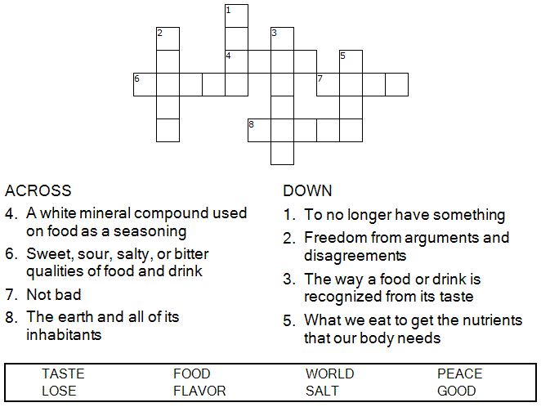

*Word Search Puzzle*

*Crossword Puzzle*



**  

**2021 CHURCH LEADERSHIP**

**COUNCIL OFFICERS**

Larry Smith, President

Bob Oster, Vice President

Brooke Breland, Secretary

**COUNCIL MEMBERS**

Dede Conover-Blankenship, Fellowship Committee Liaison

Will Breland, Outreach Committee Liaison

Bob Peters, Facilities Committee Liaison

Marie Prine, Worship Committee Liaison

Tracy Teague, Learning Committee Liaison

OPEN Stewardship Committee Liaison

**COMMITTEE CHAIRS**

John Boettner, Worship

Rachel Brunswick, Learning

Mike Huckabaa, Facilities

Susan Pritchett, Fellowship

Dennis Steul, Stewardship

Jeanne Trammell Outreach/Witness (Temporarily contact Susan Pritchett)